# Hands-on Experiment # 3 : Worksheet

Section______________ Date__________________________________

No more than 3 students per one submission of this worksheet.

Student ID _________________________________ Name______________________________________

Student ID _________________________________ Name______________________________________

Student ID _________________________________ Name______________________________________

This time, you are provided with a new “Java101.class” as well as its source code.

The file “Java101.class” provides a new method called *Java101.typeOf()* which can be used to determine the data type of its input value.

## Part A: Indicate Resulting Data Types of Expressions with Multiple Data Types

1. Determine the data type as well as the value of each expression in the table below.
2. Write a Java program to verify that your answers (both the data types and the values) are correct.
3. Capture a screenshot showing the output of your program.

|  |  |  |
| --- | --- | --- |
| Expression | Data Type | Value |
| 20.0/2.5 | double | 8.0 |
| “3”+2+1 |  |  |
| 5+“6”+7 |  |  |
| 4/6*3 |  |  |
| 3.0/4*4 |  |  |
| (short)1.5 |  |  |
| 3+2.0F+4.0 |  |  |
| 4-6==7-9 |  |  |
| (int)(5-6.5)==1-2 |  |  |

List the source code of you program below.

Insert the screenshot below.

## Part B: Random Number Generator

In this part, you will write a “random generator” program.

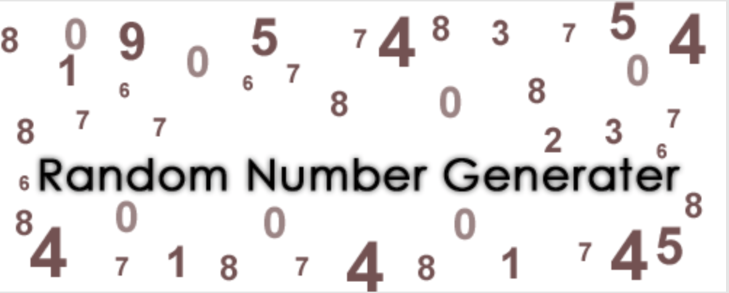

A random number generator that generates integer number from 1 to 10 and normally distributed with an average of 5 and standard deviation of 2.

*An execution of the program generate an integer number.*

The file “Java101.class” also provides a method called *Java101.showRomanNumber()* which takes an int value as its input. When invoked, the method shows a Roman numeric associated with the input value.

1. Study the following two methods: *java.util.Random()* and *java.lang.Math.ceil()* from

<http://docs.oracle.com/javase/8/docs/api/index.html>

1. Come up with a Java expression using *Random()*, *Math.ceil()*, and an appropriate cast operator so that the expression produces a random int value in the range of 1 to 10 that is normally distributed with an average of 5 and standard deviation of 2.
2. Write a Java program that performs the number generation described. Name the program appropriately.
3. List the source code as well as screenshots of the program.

Hint: nextGaussian() returns the next pseudorandom, Gaussian ("normally") distributed double value with mean 0.0 and standard deviation 1.0 from this random number generator's sequence.

Show your Java expression in step 2 here.

Also, list the source code of the program you wrote below.

Insert the screenshots below.

## Part C: Test the Random Number Generator

1. Run the program you wrote in Part B 30 times. Note the result of each generation in the table below.

|  |  |  |  |  |  |
| --- | --- | --- | --- | --- | --- |
| Trial # | Result | Trial # | Result | Trial # | Result |
| 1 |  | 11 |  | 21 |  |
| 2 |  | 12 |  | 22 |  |
| 3 |  | 13 |  | 23 |  |
| 4 |  | 14 |  | 24 |  |
| 5 |  | 15 |  | 25 |  |
| 6 |  | 16 |  | 26 |  |
| 7 |  | 17 |  | 27 |  |
| 8 |  | 18 |  | 28 |  |
| 9 |  | 19 |  | 29 |  |
| 10 |  | 20 |  | 30 |  |

1. Calculate mean and standard deviation of generated numbers.

**Mean (Average) =**

**Standard Deviation (SD) =**